Practical No. 1

Objectives: Implement IP SLA

* Configure and verify the IP SLA feature.
* Test the IP SLA tracking feature.
* Verify the configuration and operation using show and debug commands.

Topology:

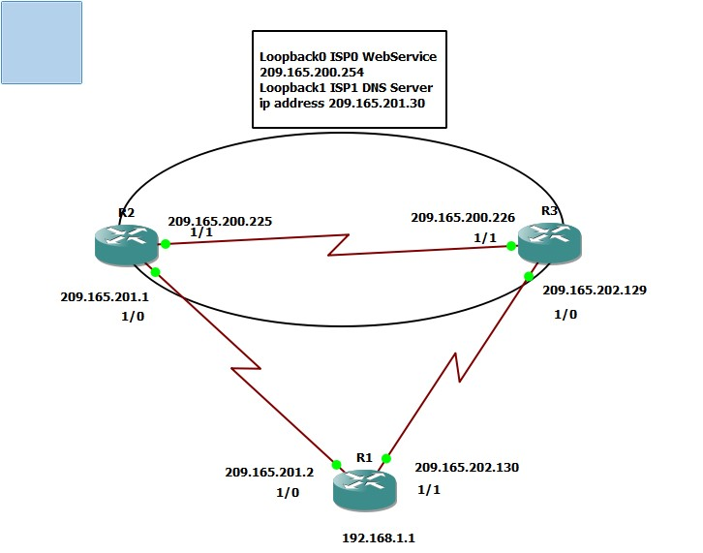

Step 1: Configure loopbacks and assign addresses.

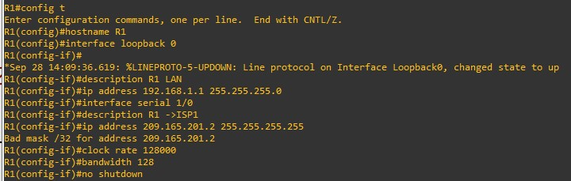

Router R1

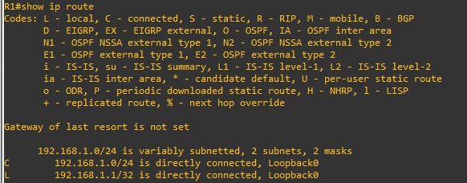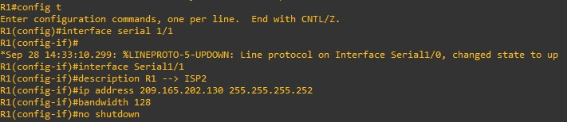

Router ISP1 (R2)

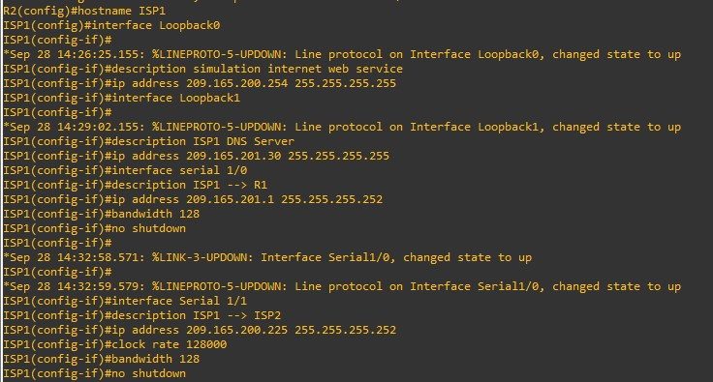

Router ISP2 (R3)

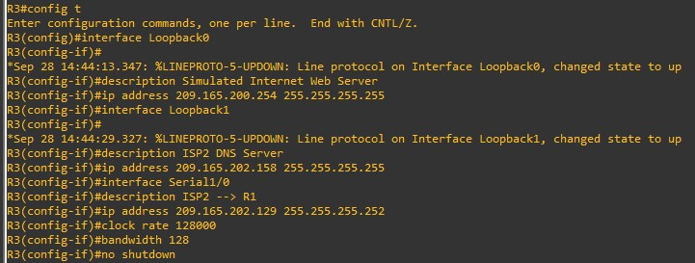

Verify the configuration by using the show interfaces description command. The output from router R1 is shown here as an example.

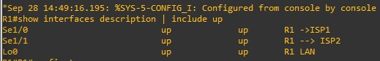

Step 2: Configure static routing.

Router R1

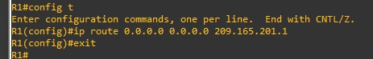

Router ISP1 (R2)

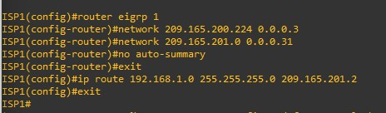

Router ISP2 (R3)

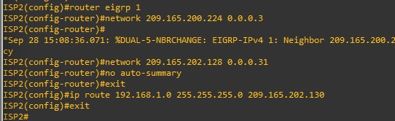

Before implementing the Cisco IOS SLA feature, you must verify reachability to the Internet servers. From router R1, ping the web server, ISP1 DNS server, and ISP2 DNS server to verify connectivity. You can copy the following Tcl script and paste it into R1.

foreach address { 209.165.200.254

209.165.201.30

209.165.202.158

} { ping $address source 192.168.1.1

}

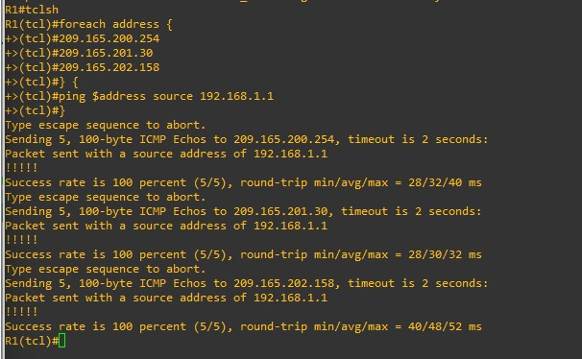

Trace the path taken to the web server, ISP1 DNS server, and ISP2 DNS server. You can copy the following Tcl script and paste it into R1.

foreach address { 209.165.200.254

209.165.201.30

209.165.202.158

} { trace $address source 192.168.1.1 }

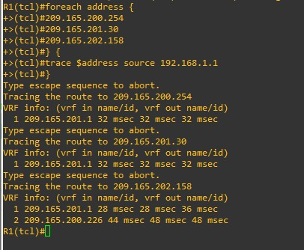

Step 3: Configure IP SLA probes.

1. Create an ICMP echo probe on R1 to the primary DNS server on ISP1 using the ip sla command.

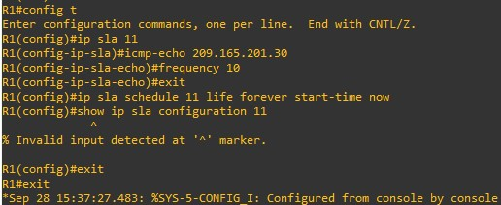

1. Verify the IP SLAs configuration of operation 11 using the show ip sla configuration 11 command.

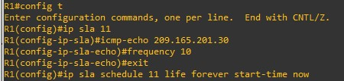

1. Issue the show ip sla statistics command to display the number of successes, failures, and results of the latest operations.

R1# show ip sla statistics

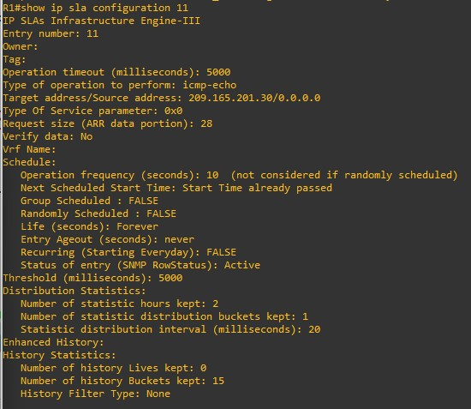

1. Although not actually required because IP SLA session 11 alone could provide the desired fault tolerance, create a second probe, 22, to test connectivity to the second DNS server located on router ISP2.

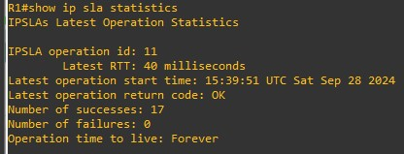

Verify the new probe using the show ip sla configuration and show ip sla statistics commands.

R1# show ip sla configuration 22

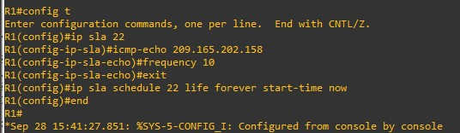

R1# show ip sla configuration 22

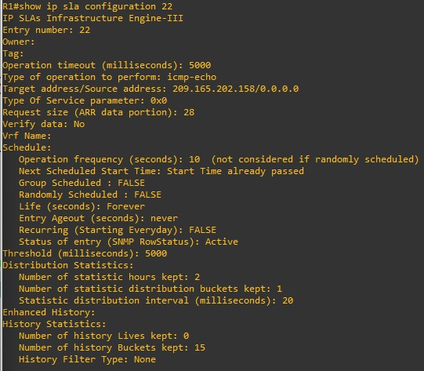

R1# show ip sla statistics 22

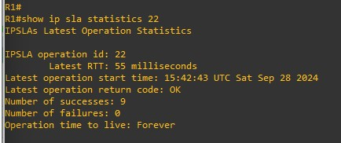

Step 4: Configure tracking options.

1. On R1, remove the current default route and replace it with a floating static route having an administrative distance of 5.

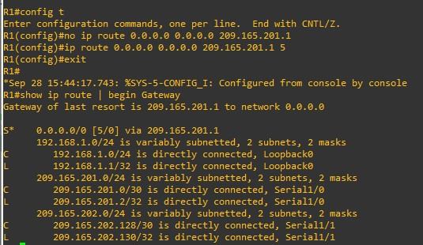

1. Verify the routing table.

R1# show ip route | begin Gateway

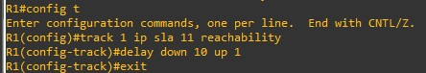

1. From global configuration mode on R1, use the track 1 ip sla 11 reachability command to enter the config-track subconfiguration mode. R1(config)# track 1 ip sla 11 reachability



1. Specify the level of sensitivity to changes of tracked objects to 10 seconds of down delay and 1 second of up delay using the delay down 10 up 1 command. The delay helps to alleviate the effect of flapping objects— objects that are going down and up rapidly. In this situation, if the DNS server fails momentarily and comes back up within 10 seconds, there is no impact.

R1(config-track)# delay down 10 up 1

1. To view routing table changes as they happen, first enable the debug ip routing command.

R1# debug ip routing

IP routing debugging is on

R1#

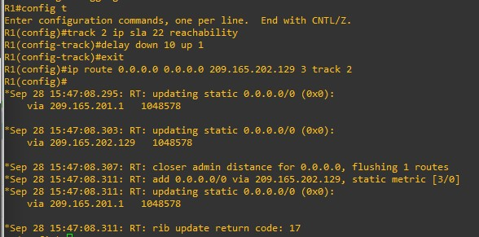

1. Configure the floating static route that will be implemented when tracking object 1 is active. Use the ip route 0.0.0.0 0.0.0.0 209.165.201.1 2 track 1 command to create a floating static default route via 209.165.201.1 (ISP1).

Notice that this command references the tracking object number 1, which in turn references IP SLA operation number 11.

R1(config)# ip route 0.0.0.0 0.0.0.0 209.165.201.1 2 track 1

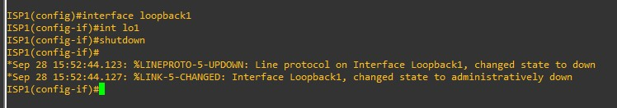

1. Repeat the steps for operation 22, track number 2, and assign the static route an admin distance higher than track 1 and lower than 5. On R1, copy the following configuration, which sets an admin distance of 3.

R1(config)# track 2 ip sla 22 reachability



1. Verify the routing table again.

R1#show ip route | begin Gateway

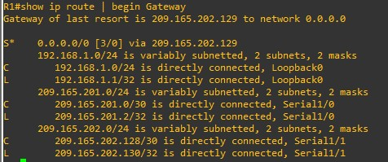

Step 5: Verify IP SLA operation.

1. On ISP1, disable the loopback interface 1.
2. On R1, observe the debug output being generated. Recall that R1 will wait up to 10 seconds before initiating action therefore several seconds will elapse before the output is generated.
3. On R1, verify the routing table.

R1# show ip route | begin Gateway

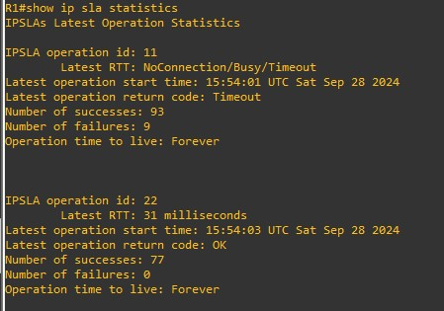

1. Verify the IP SLA statistics.
2. On R1, initiate a trace to the web server from the internal LAN IP address.

R1# show ip sla statistics

R1# trace 209.165.200.254 source 192.168.1.1

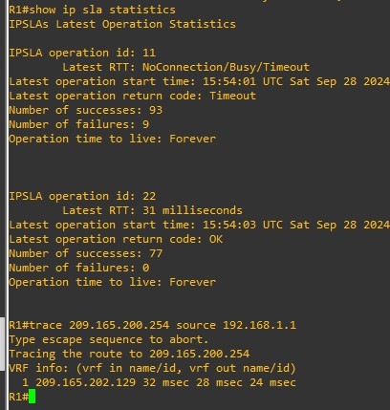

1. On ISP1, re-enable the DNS address by issuing the no shutdown command on the loopback 1 interface to examine the routing behavior when connectivity to the ISP1 DNS is restored.

ISP1(config-if)# no shutdown

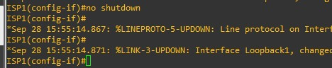

Notice the output of the debug ip routing command on R1.

1. Again examine the IP SLA statistics.

R1# show ip sla statistics

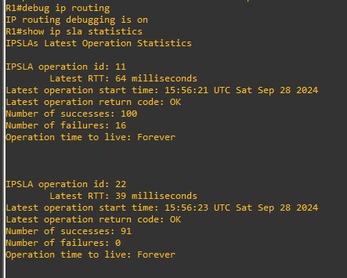

1. Verify the routing table.

R1# show ip route | begin Gateway

